Exercise 7: Financial Forecasting

Recursive Algorithm:
Recursion is a programming technique where a method calls itself to solve a problem.
It breaks a large problem into smaller subproblems of the same type, making the solution more readable and logical.
In the context of financial forecasting, recursion is useful because:
- Each future value depends on the previous year’s value.
- Instead of using loops, recursion allows you to express growth step-by-step.

CODE :

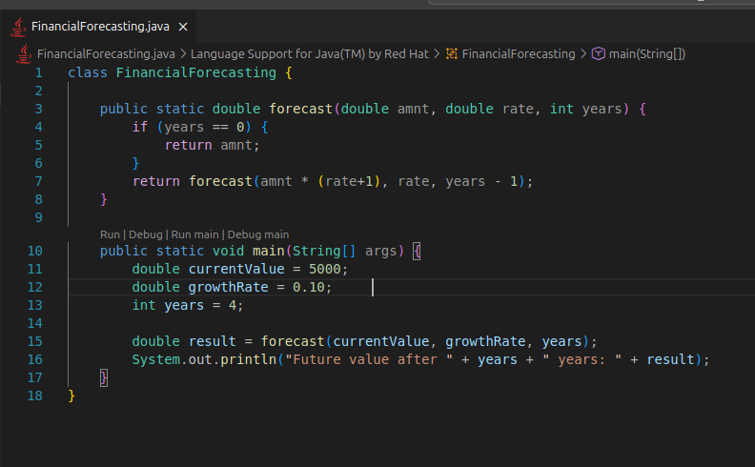

Output :

Time Complexity:
- The function calls itself once per year.
- So, for n years, it performs O(n) recursive calls.
- Each call does constant work so the overall complexity is linear.

